🦾 Survivors
Game Rules
Character Sheet Template
(click -> open preview -> Ctrl+A -> copy-paste under the last survivor and edit according to the Character Creation rules)
OR just take one of the Unoccupied Character slots below!

Dead Panic Content Download

The Survivors
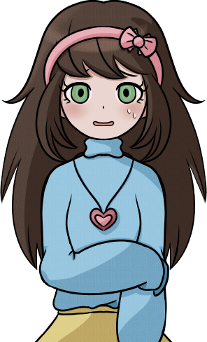 |  |  |  | Winnie Sage (DL) |  |  |  |  | Smiles
 |  |  |  | A small, hyper-aware young lady who’s much more durable than she seems. Winnie’s TERRIFIED, and all she wants is to see her family again.
 |  |  |  | Attributes |  |  | Danger Level:  Perfect |  | Describe wounds here.
 |  |  |  | Form |  | 1
 |  |  |  | Endurance |  | 4 | Buffs
 |  |  |  | Awareness |  | 5
 |  |  |  | Scavenging |  | 2 | Debuffs
 |  |  |  | Technology |  | 3
Special Perks |  |  |  |  |  | Trauma
Behind You! |  | During combat, gain the ability to give a Survivor +2 bonus to an Endurance roll to evade a grab or attack as a Slow Action (2 AP cost). |  |  |  | Touch Averse |  | If grabbed by a zombie, cannot attempt to escape on her next action.  + Special Perk
Hyper-Aware |  | Automatically senses danger in every new area, still has to roll awareness to identify the cause.

💼Inventory
Surgical Circular Saw  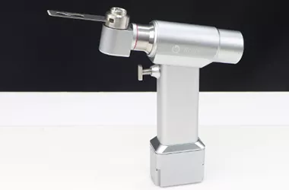 |  |  | An orthopedic surgical saw.  2 DMG  Durability: 2  Range: Engaged |  |  |  |  |  |  | Big weapon slot.
Item Name  <Item Icon> |  |  | Item Description. |  |  |  |  |  |  | Small weapon slot.
Snacks [2]  <Item Icon> |  |  | S u s t e n a n c e . |  |  |  |  |  |  | Usable item slot.
Item Name  <Item Icon> |  |  | Item Description. |  |  |  |  |  |  | Usable item slot.

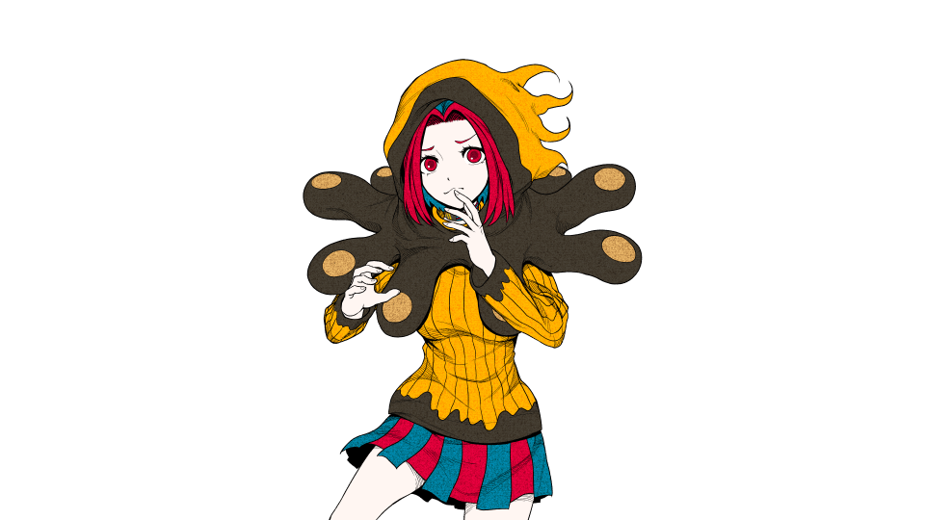 |  |  |  | Anzu Kinashi |  |  |  |  | Geck
 |  |  |  | A young, friendly girl who had a side job of being a clown before the zombie apocalypse hit. REALLY not prepared for this sort of experience.
 |  |  |  | Attributes |  |  | Danger Level:  Worry |  | Her neck got scratched. It's not a deep wound but it looks painful.
 |  |  |  | Form |  | 2 (3)
 |  |  |  | Endurance |  | 4 | Buffs
 |  |  |  | Awareness |  | 4 (5)
 |  |  |  | Scavenging |  | 4 | Debuffs
 |  |  |  | Technology |  | 1
Special Perks |  |  |  |  |  | Trauma
Life of the Party |  | Can attempt to cheer up an injured survivor (except self). Flip a coin. On heads, the survivor’s injury is Cured to Perfect from sheer positivity, unless it's a zombie bite.  However, on Tails, flip a coin again. If you get Tails again - gains a new Trauma - Broken Clown, destroying this perk in the process. |  |  |  | Sad Clown |  | If not with at least one other survivor, all stats -2. (Cannot reduce a stat below zero.)  + 1 Form  + 1 Awareness
 |  |  |  |  |  | Broken Clown  (gained if "Life of the Party" fails) |  | When attempting any action in combat, flip a coin. On tails the action automatically fails.

💼Inventory
Lead Pipe  <Item Icon> |  |  | Busts some heads.  Durability 4  Damage 1  DC 7  Form |  |  |  |  |  |  | Big weapon slot.
 |  |  |  |  |  |  |  |  |  | Small weapon slot.
Snacks [2]  <Item Icon> |  |  | S u s t e n a n c e . |  |  |  |  |  |  | Usable item slot.
"Vaccine"  <Item Icon> |  |  | Just a drop of a clear, blue liquid in this one. |  |  |  |  |  |  | Usable item slot.

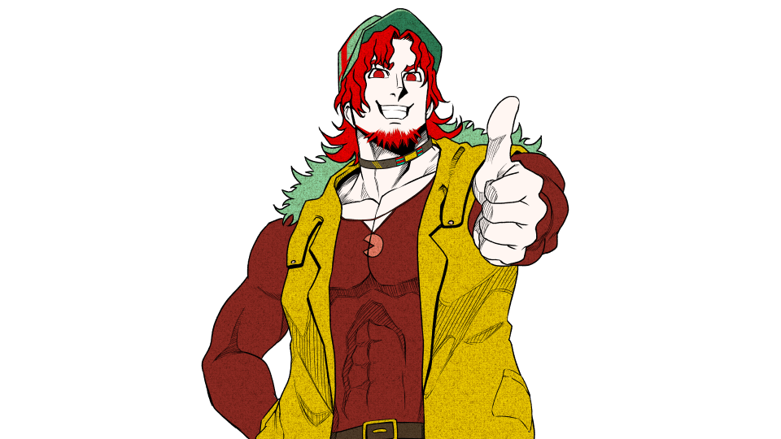 |  |  |  | Max Form |  |  |  |  | RJ
 |  |  |  | A college student who was obsessed with fitness and protecting his friends. Now the last of his class and is roaming alone. Hasn’t encountered someone in months
 |  |  |  | Attributes |  |  | Danger Level:  Worry |  | A nasty bruise on his left shoulder
 |  |  |  | Form |  | 5 (6)
 |  |  |  | Endurance |  | 5 | Buffs |  | "Dependable"  +1 Form
 |  |  |  | Awareness |  | 2
 |  |  |  | Scavenging |  | 2 | Debuffs
 |  |  |  | Technology |  | 1
Special Perks |  |  |  |  |  | Trauma
Paranoia |  | +2 to Awareness when alone |  |  |  | Autophobia |  | The fear of being alone or abandoned. When alone their form is decreased by 2. Cannot initiate combat when alone.  + Special Perk
Dependable |  | +1 Form when Injured  (Danger Level at Worried or higher) |  |  |  | Atychiphobia |  | Fear of failing others. When witnessing the death of another player, lower all stats by 1 with the exception of form  + Special Perk
Protective Instincts |  | When a player who currently has an injury is about to receive another, the user may instead decide to take the injury for them.

💼Inventory
Item Name  <Item Icon> |  |  | Item Description. |  |  |  |  |  |  | Big weapon slot.
Combat Knife  <Item Icon> |  |  | Backstabs instakill straggler zombies.  2 DMG  Durability: 4  Range: Engaged  DC 7 |  |  |  |  |  |  | Small weapon slot.
Snacks [2]  <Item Icon> |  |  | S u s t e n a n c e . |  |  |  |  |  |  | Usable item slot.
Item Name  <Item Icon> |  |  | Item Description. |  |  |  |  |  |  | Usable item slot.

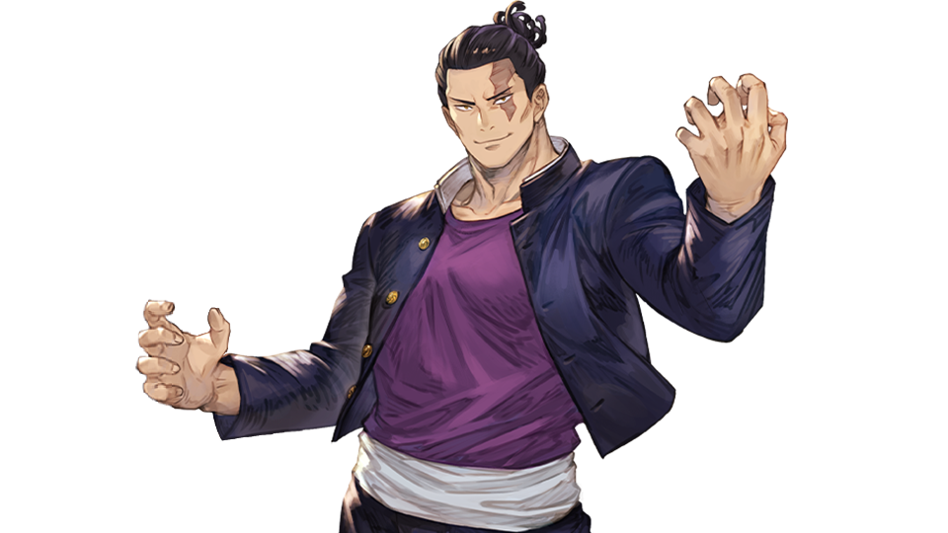 |  |  |  | AOI TODOOO |  |  |  |  | Rey
 |  |  |  | He is THE Todo. The one and only
 |  |  |  | Attributes |  |  | Danger Level:  Danger |  | He has a nasty scratch on his chest. His left arm also has a laceration.
 |  |  |  | Form |  | 2
 |  |  |  | Endurance |  | 3 (5) | Buffs |  | "Behind You!" (Winnie)  +2 Endurance
 |  |  |  | Awareness |  | 2
 |  |  |  | Scavenging |  | 3 | Debuffs
 |  |  |  | Technology |  | 5
Special Perks |  |  |  |  |  | Trauma
TODO TECHNOLOGY |  | Can repair smart devices and create simple technology from scraps. |  |  |  | Trauma Name |  | Trauma description

💼Inventory
Item Name  <Item Icon> |  |  | Item Description. |  |  |  |  |  |  | Big weapon slot.
9mm Handgun  <Item Icon> |  |  | It’s a pistol and it shoots. Two magazines. (9/12)  Technology  DC 6  +3 DC in Engaged Range  Range: Long |  |  |  |  |  |  | Small weapon slot.
Uniforms and lab coats  <Item Icon> |  |  | Item Description. |  |  |  |  |  |  | Usable item slot.
Item Name  <Item Icon> |  |  | Item Description. |  |  |  |  |  |  | Usable item slot.

📏 Rules
Template Link Please keep the template doc link if you are to use this template. You are free to remix, modify and adapt this doc to your liking as long as you credit the author(s). Doc and mechanics created by Crystalwarrior.

Dead Panic
Welcome to the Zombie Apocalypse! Shamble shamble🧟‍♀️🧟‍♂️

Game Rules

General
- Roleplay Rules - Read this! This is important!

Character Creation
- Select All and Copy this character sheet, paste it into the Survivors tab and fill out these sections (or fill it out as its own doc and send it to the GM if this doc is in View Mode):
  - Character Name - your character's name. Can be anything
  - Player Name - your OOC name.
  - Character Description (optional) - a brief summary of the character.
  - Character Image (optional) - image of the character. Can just be their sprite.
  - Attributes - 15 points to spend at initial creation. Minimum of 1 in each stat, maximum of 5 in any particular stat.
Attributes (min 1, max 5) |  | Explanation
Form | 1 | Your physical fitness and strength. Ability to dish out punishment, using weapons, pushing, pulling and carrying hard objects.
Endurance | 2 | Dodging attacks. Running from pursuers. Overcoming pain, tolerance to substances, poisons.
Awareness | 3 | Detecting ambushes. Identifying hidden threats.
Scavenging | 4 | Discover useful items, searching.
Technology | 5 | Mechanisms and crafting. Also frequently used for firing guns.
Points Total | No more than 15
  - Special Perks - Your starting perk, as described below (rule 4)
  - Trauma - either a debilitating injury, loss of limb, or an action your character will absolutely refuse to do, or a massive debuff to a stat like -2, or loss of your other perk.
    - However, gain either 1 extra perk, or 2 points to spread on any of your attributes.
  - Inventory - Any items gained from your perk or collected during the game.
- Your character may be a custom. However, you must provide a link to your custom character.
  - Links must be provided before the sign-up deadline is reached. Otherwise you may be asked to switch to a base content character.
- Each character will gain one (1) unique perk at the start of the session. Examples of a perk include: sensing if there is danger whenever you enter a new area, gaining one extra inventory slot, starting with a specific item without needing to scavenge for it, an additional bonus in certain stat rolls, and whatever else the user may come up with.
  - The player may be able to freely come up with any kind of perk they want, so long as this perk is approved at the GM's discretion.
  - You are allowed to ask the GM for assistance in creating a perk.

Inventory Rules
- Survivors have a limited inventory. They may have:
  - 1 Big Weapon (axe, spear, sledgehammer)
  - 1 Small Weapon (knife, screwdriver, hammer)
  - 2 Usable Items (first-aid kit, bandages)
- Survivors may exchange items with each other, or put them on the ground.

Exploration

Overview
- Undead Panic is capable of being run using only a single area for the entire duration of the session, choosing to switch BG’s whenever the entire party moves together to a new location.
  - However, in the event that the party has chosen to be split up, the utilization of other areas is possible.
  - The GM may also prepare an explorable multi-area location for you, utilizing the area descriptions or the evidence system as necessary.
- During the exploration phase, there is no turn order on which survivor may go first. You are allowed to describe the action you wish to perform at any time.
- Survivors may be able to interact with their environment as they wish, whether it be scavenging, searching for information on a computer, boarding up the windows of a house, and so on. A GM will then ask you to roll if necessary. Rolls use one or several of the survivor attributes. The number must be equal to or higher than the Difficulty Check (DC) to see if your action passes. For example:
The Difficulty Check (DC) is 6. You are asked to roll Scavenging, which is 3 for you. In OOC you use:
/roll 1d6 +3
With the resulting roll being 3 + 3 = 6, your Scavenging action passes.
  - You do not need to roll for an action unless the GM explicitly tells you to do so.
  - If your roll doesn't pass (you roll under the DC) your action either succeeds with complications, or fails entirely. Only actions that may not be repeated can fail, and failure results in consequence.
As an example of a "succeed with complications" action:
if you kick open a jammed door, but you did not pass the DC, you still succeed in kicking it open. However, your leg gets caught inside the door. The complication becomes suffering an injury to your leg.
  - If asked, the GM must respond if the action can fail entirely, or succeed with complications.
- The exploration phase does not end if survivors encounter a single zombie - they may be ambushed, suffer injuries and dispatch straggler zombies. However, encountering a horde of zombies will result in the Combat Phase.

Combat

Overview
- When combat begins, initiative is decided by comparing each participant’s Form stat. If multiple Survivors have the same Form, they decide between each other who goes first (if no decision is reached, GM decides for them). After that, Combat alternates between Survivors and the Zombie Horde.
- Combat proceeds in turns. On each turn, every participant has access to 3 Action Points (AP).
  - Slow Actions cost 2 AP
  - Fast Actions cost 1 AP
- Combat ends only when:
  - All zombies are destroyed
  - All survivors are dead
  - The survivors escape the encounter

Slow and Fast Actions

Slow Actions (2 AP) include:
- Attacking
- Reloading a weapon
- Performing a major objective (e.g. refueling, rebooting a system)
- Aiming (grants +1 die on your next ranged attack)
- Picking up an item/weapon off the ground
- Switching items/weapons with another survivor

Fast Actions (1 AP) include:
- Moving one range category
- Switching weapons
- Opening or closing a door
- Taking cover
- Survivors may be able to pass their turn to allow the next player in the turn order to immediately go next. This is usually done in service of allowing the Survivor with the highest stat to perform a specific action that will be best done by them, and has the least odds of failing.
  - Survivors who chose to pass their turn will be moved to the last of the turn order.

Attacking
- To attack, a Survivor must have a weapon. Weapons have defined attributes and its difficulty check, damage, range, and special effects detailed in their item descriptions.
- Each weapon is tied to one or multiple of the survivor's Attributes. To make an attack, you must make rolls for each attribute, and succeed at overcoming the Difficulty Check (DC) for that weapon.
- Any failed attribute roll reduces the damage by 1. If the damage is reduced to 0:
  - For melee weapons, it's treated as a shove. Useless for damage, but will free any grabbed teammates.
  - For ranged weapons, it's a miss, no damage is applied and the ammo is wasted.
- Weapons require the survivor's target to be within the weapon's effective range.

Ranges in Combat
Combat distance is abstracted into range bands:
- Engaged – Face to face with the enemy
- Short – A few meters away
- Medium – Up to 25 meters
- Long – Up to 100 meters
- Extreme – Up to 1 kilometer
- To leave Engaged range, a Survivor must make a Form Check. On a fail, the Survivor still escapes, but the enemy gets a free attack.

Ranged Weapons
- Most ranged weapons have limited ammunition, tracked by a number next to the weapon.
- Certain weapons have magazines/clips and their capacity, which is formatted like such:
4/12 (x2) means you have 4 bullets in a 12 capacity magazine/clip, and you have 2 spare magazines/clips left. (For the purposes of this system and simplicity, both magazines and clips are handled by the same rule unless specified otherwise).
- Some ranged weapons are unlimited, but may have durability instead, which decreases with each use.
- If a ranged weapon is usable as a melee weapon that will also decrease its durability.
- Some weapons may have recoil - after each shot, the survivor must struggle to stay upright by rolling Form. Otherwise, they will have to waste a slow action to get up next turn.

Melee Weapons
- Melee weapons may have durability, which decreases with each use.
- A weapon is considered melee if its effective range does not go beyond "short".

Other Actions
- During the Combat Phase, Survivors may still be able to perform other actions and interact with their environment, if they are not currently knocked down or grabbed by a zombie.
  - However, they will still be governed by the Turn Order, and will need to use up one of their Fast or Slow Actions depending on what they choose to do.
  - As an example, these actions are typically done in service of being able to perform a Combative Action. Such as scavenging for items to utilize in combat, crafting a weapon in the middle of an encounter, etc.

Passing a Turn
- Passing a turn is simply choosing to act last in turn order. During your turn, simply say you're passing, and you'll be put at the end. Multiple survivors can pass and they will go after each other in the order of when they passed.

Fighting Zombie Hordes
- Zombie Hordes represent large groups of undead and act independently of Special Infected.
Each Horde has a Level that determines:
- How many actions it gets per round
- How many Hit Points (HP) it gets. Zombie Hit Points correspond to the Horde Level and roughly represent the difficulty of dispatching the horde.

Horde Levels
- Level 1:
  - Single zombie. 1 Action. No combat phase needed to dispatch on player turn.
- Level 2:
  - 2 Actions
- Levels 3–4:
  - 3 Actions
- Levels 5–6:
  - 4 Actions
- Levels 7-8+:
  - 5 actions, each 2 levels +1 Action
- To destroy a horde, Survivors must reduce its level to 0.
  - Zombie Horde level downgrades with each 2 damage dealt.
  - Horde levels can increase via noise, failed objectives, or environmental factors.

Horde Actions
- Attack
  - Horde rolls 1d6 + ATK, which decides the DC. All survivors in the Engaged range band must roll Endurance to dodge.
  - On a fail, the survivor's danger Level increases.
- Grab
  - Aimed at pinning Survivors. If successful:
    - The Survivor must spend their next Slow Action escaping during
  - Escaping uses the Form attribute roll, using the Horde Level + 2 as the DC.
  - You may help someone escape on your own turn instead by attacking the horde.
- Shamble
  - Close distance with the survivors, reducing the range band for everyone.

Fighting Special Infected
- Special Infected have unique mutations, stats, and turns.
- Each Special Infected has their own HP
- Survivors must reduce it to 0 to kill them
- They ignore Horde turn order and act on their own initiative

Player Health and Dying
- Survivors are not immune - they’re just lucky. That’s reflected in their Danger Level.

Survivor Health States:
- Perfect – Full combat ability
- Worry – Slightly wounded
- Danger – One more hit could mean death
If a Survivor is attacked while at Danger, they must roll 1d6 to determine bite location:
- Left Arm
- Right Arm
- Left Leg
- Right Leg
- Chest
- Neck (Instant Death)
Once bitten, the Survivor has one in-game day before turning. The only way to survive is amputation of the infected limb (if possible). If a bitten Survivor is hit again, they die instantly.

Running Away & Chase Rules
Survivors can flee combat at any time, but not without risk.
To escape:
- Survivor must reach Long Range from any enemy
- Then spend a Slow Action to exit the map
If any enemy is in Short Range or closer, a Chase begins:

Chase Mechanics:
- Roll Endurance vs ATK (Survivor vs fastest enemy)
- On a Success, Survivor gains a range band
- On a Failure, enemy closes distance and attacks
If a Survivor is grabbed or injured during a chase, they must pass an Endurance Check to keep moving.

Objectives in Combat
Sometimes, surviving isn’t enough.
Objectives can include:
- Powering a generator
- Retrieving supplies
- Protecting NPCs
- Securing an escape route
Each objective will require specific actions, often Slow Actions, and may require multiple turns or Survivors to complete.
Failure to complete an objective in time may increase Horde level, spawn Special Infected, or block escape routes.

Self-Sacrifice
In moments of desperation, Survivors may choose to sacrifice themselves to ensure the group’s survival.
Examples:
- Holding off a Horde to buy time
- Luring enemies away
- Triggering an explosion manually
A Survivor who performs a Self-Sacrifice gains a Heroic Death — their character dies, but the group gains an automatic success on the next major objective, escape roll, or defense check.

🏅 Credits
Crystalwarrior - gamemode, name and mechanics
Infinity's Dead Last - initial inspiration, inspiration for the combat system which was also based on the Year Zero Engine by Free League.
haleighleaf - Making the character sheet template

